Breast Ultrasound Image Classification

1. Methodology

1.1 Dataset & Train/Test Split
- Source: BUSI dataset (sabahesaraki/breast-ultrasound-images-dataset) downloaded via kagglehub.
- Mask exclusion: Images with filenames containing "_mask" are filtered out using is_valid_file().
- Split: 80/20 stratified train-test split, random_state = 42 (SEED). Test set = 156 samples (benign: 87, malignant: 42, normal: 27).
- Reproducibility: All random seeds fixed (Python random, NumPy, PyTorch CPU/CUDA). torch.backends.cudnn.deterministic = True.

1.2 Handling Class Imbalance
- Oversampling: Minority classes (malignant = class 1, normal = class 2) are oversampled in the training set at a 1.0× rate (100% of their training count), adding 274 augmented extra samples. Benign (class 0) is not oversampled.
- Alpha-weighted Focal Loss: Per-class alpha = [1.0, 1.2, 2.0] (benign, malignant, normal) combined with γ = 2. This down-weights easy well-classified examples and focuses training on hard minority cases.

1.3 Data Augmentation
- Pipeline (augmented copies only): Resize → 224×224, RandomHorizontalFlip, RandomRotation(±15°), ToTensor, Gaussian noise x + 0.05 × N(0,1).
- Original samples: Resize → 224×224, ToTensor only — no augmentation applied.
- Note: No Normalize() transform is applied in this version. Pixel values remain in [0, 1] (plus small noise for augmented copies).

1.4 Model Architecture — Custom CNN (422,659 parameters)
Block | Output shape | Operations | Notes
Block 1 | 112×112×32 | Conv2d(3→32,3×3,p=1), BatchNorm2d, ReLU, MaxPool2d(2)
Block 2 | 56×56×64 | Conv2d(32→64,3×3,p=1), BatchNorm2d, ReLU, MaxPool2d(2)
Block 3 | 28×28×128 | Conv2d(64→128,3×3,p=1), BatchNorm2d, ReLU, MaxPool2d(2)
Block 4 | 1×1×256 | Conv2d(128→256,3×3,p=1), BatchNorm2d, ReLU, AdaptiveAvgPool2d(1,1) | Global avg pool
Classifier | 3 | Flatten, Linear(256→128), ReLU, Dropout(0.4), Linear(128→3)

1.5 Training Configuration
Setting | Value
Optimiser | Adam (lr = 1×10⁻⁴)
Loss | Focal Loss (γ = 2, α = [1.0, 1.2, 2.0] for benign / malignant / normal)
Epochs | 15
Batch size | 32
Input size | 224 × 224 × 3 (RGB)
Train batches / Test batches | 29 / 5
Augmented extra samples | 274 (malignant × 1.0 + normal × 1.0)

2. Results

2.1 Per-Class Classification Report
Class | Precision | Recall | F1-Score | Support
Benign | 0.76 | 0.77 | 0.77 | 87
Malignant | 0.62 | 0.76 | 0.68 | 42
Normal | 0.81 | 0.48 | 0.60 | 27
Overall accuracy | — | — | 0.72 | 156
ROC-AUC (macro OvR) | — | — | 0.868 | —

2.2 Confusion Matrix
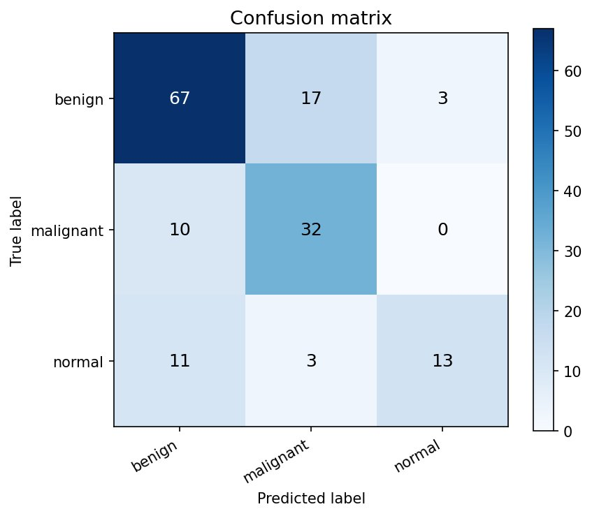

2.3 Training Curves
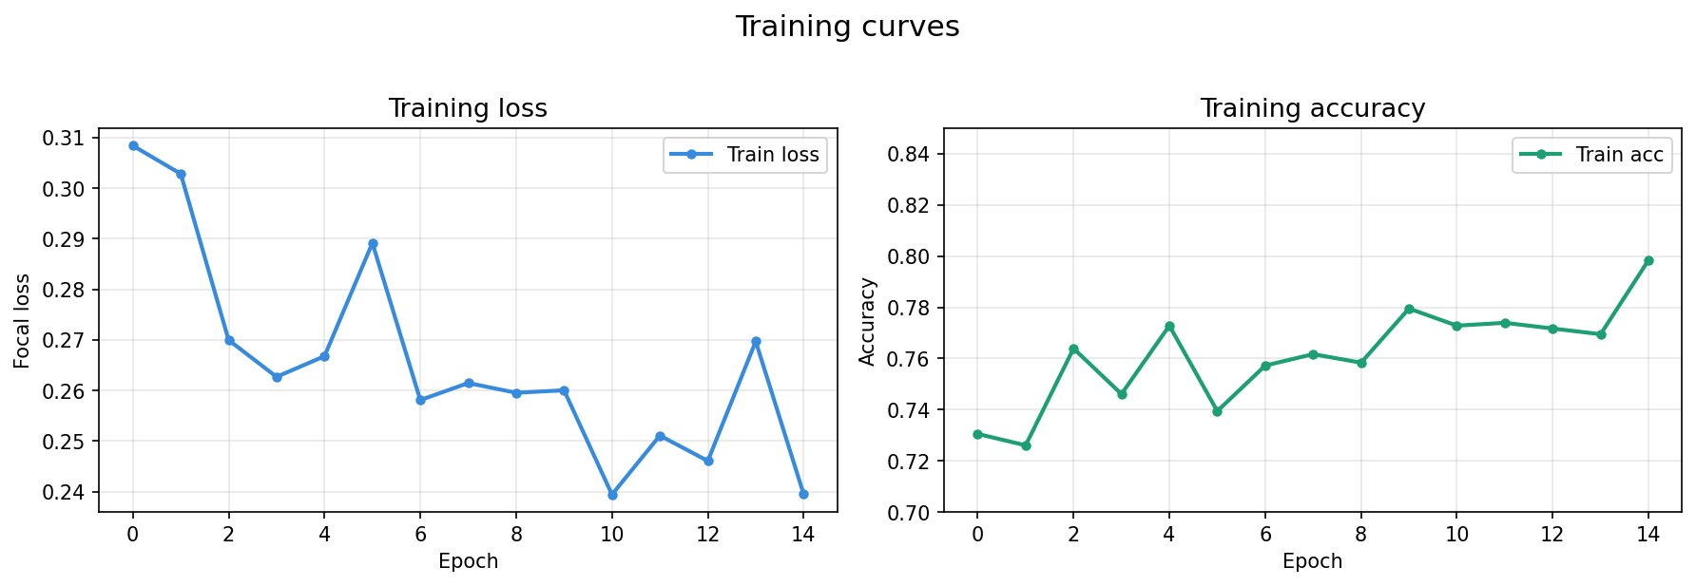

2.4 ROC Curves
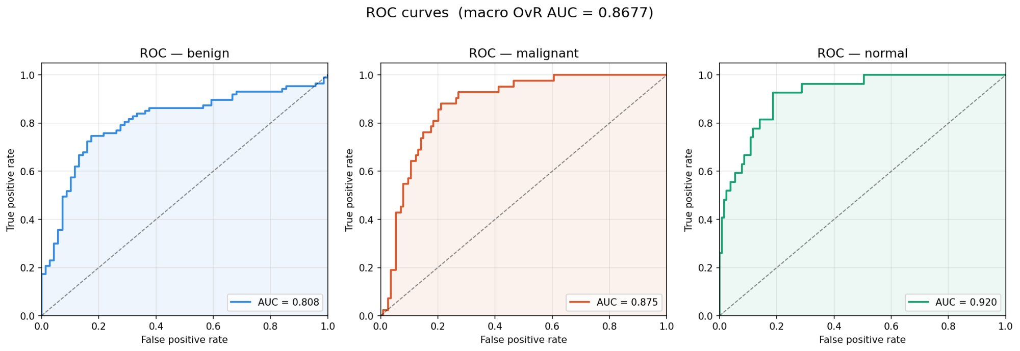

3. Key Observations
- Overall accuracy 72%, ROC-AUC 0.868 — the model discriminates well at the probability level even though hard-label accuracy is moderate.
- Benign (recall 77%): 17 cases wrongly predicted as malignant, 3 as normal. Largest class and hardest boundary.
- Malignant (recall 76%): 10 misclassified as benign; 0 confused with normal — the clinically critical benign↔malignant boundary is partially controlled.
- Normal (recall 48%): Weakest class. 11 of 27 normal samples predicted as benign. Likely caused by visual overlap and the smallest support (27 test samples).
- Training instability: Loss and accuracy oscillate across epochs (no LR scheduler, no Normalize() transform). Adding CosineAnnealingLR and normalisation are the immediate next steps.
- No input normalisation: The normal_transform pipeline omits Normalize(). This slows convergence as pixel values are not zero-centred for the conv layers.

